H.T No
Regulations:
A18

Sreenidhi Institute of Science and Technology
(An Autonomous Institution)
Code No: 7AC07 Date: 07-Sept-2021(FN)

B.Tech II-Year II- Semester External Examination, Aug/Sept-2021 (Regular)
CONTROL SYSTEMS (EEE)

Time: 3 Hours Max.Marks:70

Note: a) No additional answer sheets will be provided.
b) All sub-parts of a question must be answered at one place only, otherwise it will not be valued.
c) Missing data can be assumed suitably.

ANSWER ANY 5 OUT OF 8 QUESTIONS. EACH QUESTION CARRIES 14 MARKS.

Bloom's Cognitive Levels of Learning (BCLL)

Remember | L1 | Apply | L3 | Evaluate | L5
Understand | L2 | Analyze | L4 | Create | L6

 |  |  | BCLL | CO(s) | Marks
1. | a) | Obtain the transfer function of the below feedback control system using signal flow graph method.  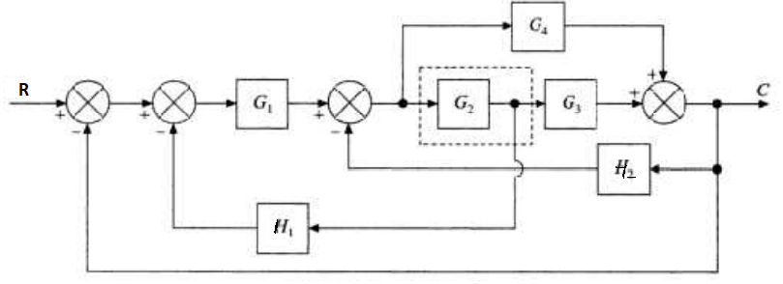 | L3 | CO1 | [10M]
 | b) | Define transfer function of a system. | L1 | CO1 | [4M]
2. | a) | A unity feedback system is characterized by an open -loop transfer function  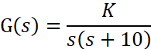  Determine the gain K so that the system will have a damping ratio of 0.5. For this value of K determine the settling time, peak overshoot and time to overshoot for a unit step input. | L4 | CO2 | [10M]
 | b) | How are control systems classified depending on the value of damping? | L2 | CO2 | [4M]
3. | a) | Determine the stability of the system represented  S⁶+3S⁵+ 5S⁴+9S³+8S²+6S+4=0  using Routh criterion. Also determine the number of roots of characteristic equation in right half of s-plane if system is unstable. | L3 | CO3 | [10M]
 | b) | Explain how are the roots of characteristic equation related to stability. | L2 | CO3 | [4M]
4. | a) | Draw the Bode plot for the following transfer function and determine the system gain crossover frequency, phase crossover frequency, gain margin and phase margin. Also determine the value of K for a phase margin of 45⁰.  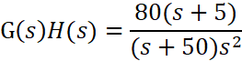 | L4 | CO4 | [10M]
 | b) | Define resonant peak and resonant frequency. | L1 | CO4 | [4M]
5. | a) | Write the procedure for the design of a PID controller. | L2 | CO5 | [10M]
 | b) | What is a lead compensator and when it is preferred? | L2 | CO5 | [4M]
6. | a) | Given the system 𝑥̇(t ) = A x(t )+ B u(t ), Y(t) = C x(t) Where  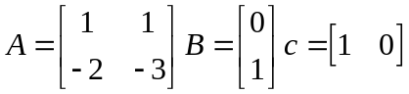  Determine the state controllability, output controllability and observability of the system | L5 | CO6 | [7M]
 | b) | Derive the state space model for a series RLC circuit excited with a source of V(t) | L3 | CO6 | [7M]
7. | a) | Write the differential equations governing the behaviour of the mechanical system shown in figure below  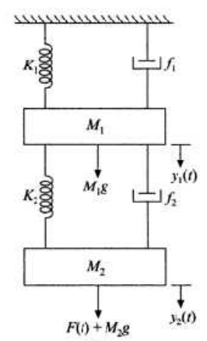 | L3 | CO1 | [5M]
 | b) | Define delay time and settling time. | L1 | CO2 | [5M]
 | c) | What are the advantages and drawbacks of Routh stability criterion. | L1 | CO3 | [4M]
8. | a) | What are the advantages of frequency response analysis? | L1 | CO4 | [5M]
 | b) | What is the effect of addition of a zero to G(s)H(s) on the Nyquist plot? | L4 | CO5 | [5M]
 | c) | Relate transfer function of a system to it’s state model. | L2 | CO6 | [4M]

-- 00 -- 00 –

